Ashtakavarga system of prediction in vedic astrology
We know that in order to come to certain definite conclusions, we need to assess not only the position of planets in the natal chart but also in transit. The transit of planets can either support or oppose the natal chart. There are some learned scholars who opine that when transits of planets oppose the planets in natal chart, the gochara scheme of things gains the upper hand. Now a days lots of people are anxious to know when Jupiter or Saturn will leave a particular sign and enter the next. One of the most dreaded transits if the sade-sathi of Saturn. But do all people perceive effect of gochara in equal measure?
The answer is “NO”. So a convenient explanation is given saying that Saturn in
his second round is beneficial, third round is not so, etc. But the real clue to deciphering the effects of planets in transit, lies in our comprehending the Ashtaka Varga system of Prediction. Now we will take a brief look at the various ways in which Astrology is used to delineate the prospects for future.
a) Natal Astrology:
For an individual the birth chart is the main building block from which all other results flow. Some times a query is raised about the results of Jupiter or Saturn in transit. If in the birth chart, Saturn is either the lagna lord or a yogakaraka or is well placed in faourable houses, then one need not worry at all where Saturn is placed in transit. For such natives, Saturn in good house in gochara may as well prove to be a boon. If, on the other hand, Saturn is a functional malefic in birth chart, then its passage over adverse houses can be indicative of critical periods to be faced.
b) Varshphal:
By casting the annual horoscope one can find out more about the immediate prospects for the forth coming year. The placement of Varsheshwar and Munthe can give a broad picture about emerging trends.
c) Prasna:
If there is a single issue bothering a person, the best way to find a solution would be to erect a prasna chart and seek answers. Generally prasna charts are valid for one question only. Deva prasana are conducted in temples to assess the mood of the presiding deity. Like this we have various types pf Prasnas for knowing about thief, Water in a well to be dug and many other specific matters.
d) Muhurtha:
The only way to overcome destiny is through free will. The best way to begin a job is to start it in an auspicious Muhurtha. This neutralizes the doshas prevailing in the natal chart. If a child has afflictions in 2nd and 4th houses, by starting his education at an auspicious moment, the basic underlying
defects can be mitigated. So whatever be one’s
birth chart or its pitfalls, an auspicious moment will invariably fetch success.
e) Mundane:
Mundane astrology generally deals with celestial phenomena such as eclipses, comets and other occurrences which have an impact over countries, continents and governments. Its main utility is the weather forecasting. It is also used to estimate prices of commodities and fluctuations therein. Amine, drought, cyclones and tidal waves also come under purview of Mundane astrology.
f) Transits:
To know what will happen at a given moment in time, the present position of planets is a major determinant and needs investigation. Though Dasa and Bhukthimay be favourable, things will not happen if in gochara planets pose impediments. There is one school of astrologers who opine that in battle between natal chart and gochara, the latter may prevail, which is perhaps when planets move through adverse houses, even people with good natal charts suffer. Having understood the various divisions of astrology, let us now turn our attention to the AshtakaVarga.
Basis of Ashtakavarga:
The word “Ashta” denotes eight. It refers to the
vargas viz. Lagna and seven planets
(excluding ………, Rahu and Kethu).
Gochara is usually seen from moon. Sometimes we looks at gochara from lagna standpoint also. For instance if lagna lord joins the 10
th
lord in transit in 10
th
house, then matters relating to profession become favourable. But, does the overall planetary position in birth chart have any impact on gochara? The Hindu Rishis gave their answer in affirmative and Ashtakavarga is a unique system devised by
them to “assess the performance of a planet in transit based
on the sum total of planetary
influences in the birth chart”.

Ashtakavarga is a very powerful system because
–
A strong influence
prevailing in Jupiter’s Ashtakavarga can override yogas for
widowhood etc.
–
Among the various systems for Ayurdaya, Ashtakavarga is the best.
–
According to Maharishi Parasara, only general predictions can be made through birth chart; definite results can be ascertained only through Ashtakavarga. Because of the elaborate reasoning given above, it would be better if all transit results are confirmed by correlating transit results with the Ashtakavarga table obtained from a
person’s Natal chart.

ASHTAKAVARGA SYSTEM OF PREDICTION Ashtakavarga system of prediction:
Once we get a horoscope for analysis, we need to exert an Ashtakavarga chart before beginning our application of rules and our analysis of its impact. Present day astrologers are fortunate to be
blessed with the “most sophisticated tools” in their armor f
or giving out their
analysis. These “tools” are nothing but software packages. Only in the late
seventies computerized packages for astrology started becoming popular. Earlier, horoscopes used to be cast manually with almanacs as an aid. The only date, a client is going to furnish would be the rasi and navamsa chart. The astrologer will be left with very little clue about exact time of birth (which will be mentioned as nazhigas and vinazhigas) or about the ayanamses used. Even the hand writing at times would be illegible. Today the entire horoscope with all data required for analysis can be obtained in less than five minutes using astrological software. But, has all this improved the quality of predictions given? This is a valid question but very difficult to answer. The only point which needs emphasis here is that in olden times, Astrologers had an excellent grasp over the subject, that even with very little inputs from the client in the form of Rasi or Navamsa charts, they could predict significant events to happen with a fair amount of accuracy. They also used to employ prasna charts to confirm their findings. Moreover, they used to memorise all the text book rules and upon seeing a chart, they can immediately detect the presence of yogas in the chart. What has now happened is that though there are number of software packages giving lots of data, astrologers do not give sufficient time and attention to them. Also clients have very little patience and seldom allow professionals to a meticulous and thorough job.
Preparation of Ashtakavarga Chart

Let us start this process from the Sun. In Sun’s Ashtakavarga, Sun is
auspicious from himself in the 1st,2nd,4th,7th,8th 9th 10th & 11th houses. Likewise Moon is auspicious in 3,6,10 & 11 from the Sun. The crucial point we need to note is that Rahu and Ketu do not yield any bind us at all. Whether lagna should be used for computing Sarvashtakavarga has been debatable issue. The Bindus of lagna add up to 49, the student has tow options
–
to include lagna thereby obtaining 386 bindus in all. Excluding lagna we get 337 bindus in the Sarvashtakavarga chart.
Rahu’s Ashtakavarga. Text books like Shambu Hora Prakash have given
bindus for Rahu as well. Now the Ashtakavarga of Rahu adds upto 43 bindus as follows:
From: Sun : 1 2 3 5 7 8 10 Moon : 1 3 5 7 8 9 10 Mars : 2 3 5 12 Mercury : 2 4 7 8 12 Jupiter : 1 3 4 6 8 Venus : 6 7 11 12 Saturn : 3 5 7 10 11 12 Lagna : 3 4 5 9 12 Now, we will have a look at the tables of all planets and see how the magic figure of 337 is arrived at. In brief, 337 bindus is actually a proess of summation of bindus obtained in each of the individual planetary chart. I wish to repeat here that lagna or rahu is not reckoned for the purpose of obtaining sarvashtakavarga of 337 bindus eventhough there is difference of opinion among learned scholars on this point. Sun 48 Moon 49 Mars 39 Mercury 54 Jupiter 56 Venus 52 Saturn 39 Total 337

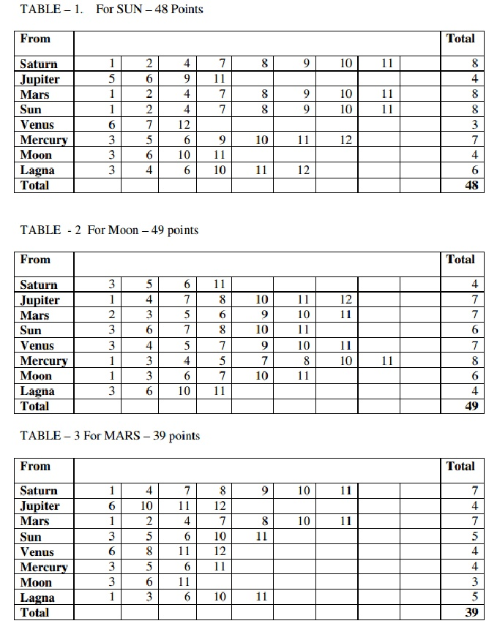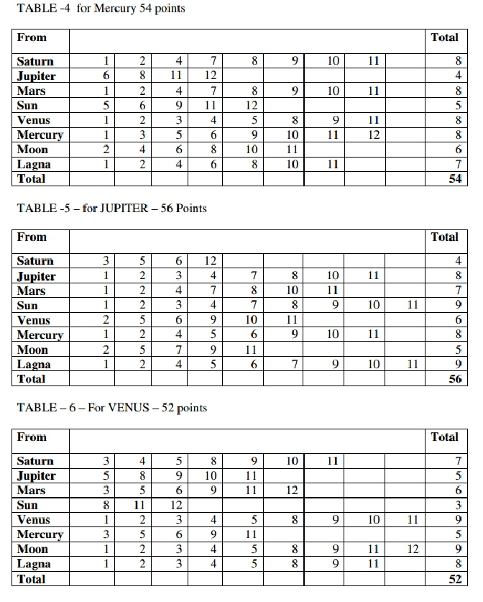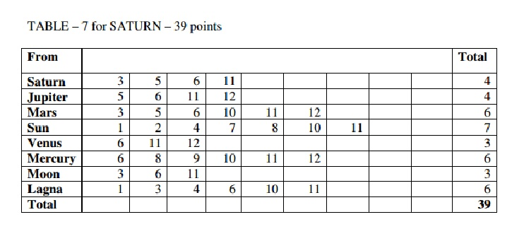

To assess the impact of a planet in transit, we need to follow the three steps mentioned below in the same serial order. 1. Find out the nature and propensity of the lords of dasa and bhukti. 2. Judge the impact of these lords in transit. Irrespective of whether they are favorable or unfavorable, the resultant impact will prove to be negligible, if
there is a planet transiting a “vedha” point from the former planet. During the
course of the dissertation, we will try to understand the meaning and impact of
“vedha” points.
3. Correlate gochara with Ashtakavarga table. Favourable planets in gochara with feeble support in Ashtakavarga do not yield desired results. Consider the case of a person running Venus dasa. There are two courses for Venus
–
one from Pisces, sign of its exaltation to Virgo and the return journey back to virgo. Virgo is the debilitation sign of Venus. So it progressively loses its strength while moving towards Virgo. So a person running Venus dasa will be benefited during its journey towards Pisces and the movement towards Virgo would prove to be otherwise.
There are a few thumb rules by which gochara rules can be understood quickly. We know the Upachaya houses are 3,6 and 11 and in a natal chart a natural malefic is good in 3,6 or 11, So the first thumb rule we need to understand is that in Gochara, Mars and Saturn are favourable in 3,6 and 11.

The above rules are also applicable to Sun. In addition Sun in 10 favours completion of some great enterprise. So in addition to 3,6 and 11, Sun is good in 10 also. What applies to Sun, applies to Rahu and Ketu also. Considering this rule, we observe, Sun, Rahu and Ketu are favorable in 3,6,10 and 11. This is the second thumb rule. Moon is favourable in 1,3,6,7,10 and 11. Venus is favorable in houses other than 6,7 and 10. Thus Moon gives good results in six houses while Venus gives good results in 9 houses. To understand this rule we need to keenly observe one point
–
As far as houses 6,7 and 10 the effects of Moon and Venus are just the opposite in terms of whether it is good or bad. This completes the third thumb rule. Mercury is favourable in all houses and in 11th (excluding 12th house). Write down all even houses. 2,4,6,8,10 12
–
Replace 12 with 11
–
2,4,6,8,10 11. This gives the list of favourable houses for Mercury. This is the fourth thumb rule. Jupiter is favourable in all odd houses (barring 1 and 3) and in 2 also. Write down all odd houses
–
1,3,5,7,9,11
–
Ignore 1 and 3 but include 2
–
2,5,7,9,11 This gives us the list of favourable houses for Jupiter and is the fifth and last thumb rule. Please note that Vedha will not act between Sun and Saturn; also between Moon and Mercury. We will now summarize all these rules in a tabular form.

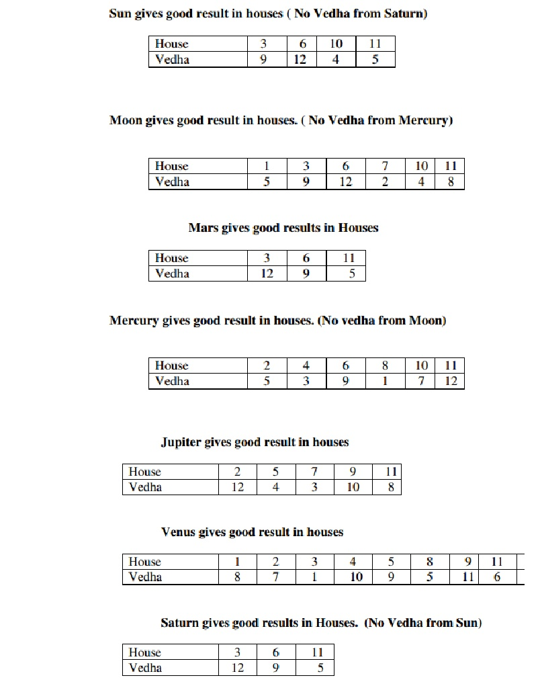
Now we are through with all the fundamental Gochara rules.However each planet in a specific house is capable of producing certain specific results.As mentioned earlier only by integration of the rules of Ashtakavarga with Gochara ,a clear picture about future trends will be obtained.In our next article we will see how planets function in producing results in transit. In our previous article we discussed about minimum number of bindus for each
bhava to become effective as well as predictiŪ

@
6eʘ^fZd3,/]BS§^]:R<E}hcle we will dwell upon further intricacies of
Ashtakavarga System of prediction. Rules of Ashtakavarga do not substitute rules of general predictive Astrology. They should be understood harmoniously or in other words, in tandem with the general rules of astrology. Saturn as we all know iQ9hmhO
ո
V
旊
- charts it is also endowed with evil qualities even functionally. Its transit over a house where bindus are less than stipulated becomes a major factor in producing adverse results. Consider the Bhinnashtavrga of Moon. For all the karaka of moon, this table is crucial. If Saturn as a malefic transits over a house where Moon has very few bindus,
then such a transit will forebode evil for the areas in a person’s life over which
Moon has control. Now we will have a brief look at what the karakatwas of major planets are:
Sun:
Father, Right Eye, Physique
Moon:
Mother, Left eye, Mind
Mars:
Immovable property, brothers
Mercury:
Education, Speech
Jupiter:
Children, Wealth, Intelligence
Venus:
Spouse, comforts of life, vehicles.
Saturn:
Labourers, servants, means of livelihood, longevity. It is important to note that a house will fare well if it has four or more bindus. The converse is also true. A house whose bindus fall short of this figure can only prodce unfortunate results. Before we discuss the effects of planets in bhavas, we need to revisit the area dealing with what each bhava denotes in a chart. This being an off-discussed and familiar area, we will mention the key points of bhavas and then proceed to the main topic.

Lagna:
1.

o
ne’s personality, phusical body.
2.

Speech, wealth, eyesight, family 3.

Courage, Co-borns, Voice, Proficiency in Music 4.

Mother, vehicles, House, Happiness. 5.

Cheildren, Merits of previous births, 6.

Debts, Diseases and enemies. 7.

Spouse, Overseas Travel 8.

Longevity 9.

Preceptor, Good Fortune, Divine grace. 10.

Work, Honour 11.

Opulence, Elder brothers 12.

Expenditure, Losses
How Planets influence a Bhava:
In brief, we will now discuss how a Planet can influence a bhava. 1.

A bhava gets destroyed when occupied by a malefic. Conversely it flourishes when aspected or occupied by a benefic. 2.

Mixed effects will be felt if both a malefic as well as benefic occupy a bhava. 3.

Planets in 6
th
, 8
th
, or 12
th
do not yield beneficial results. (Please note that if such a Planet happens to own One of the three evil house, then they mitigate the hardships thereby proving to be beneficial. Such as Hassha Yoga, Vimala Yoga, Sarala Yoga and Vipareetha Yoga operate on this principle). 4.

A malefic in own house or exaltation yields good results. 5.

A benefic in debilitation or getting combusted loses its benefic power and therefore yields bad results. Any student of Astrology who can understand the essence of these principles can easily forecast the outcome of each bhava in a horoscope. If the bhava, bhava lord and karaka are strong and are also well placed, the good effects of that bhava are assured. However Sun in 9, Moon in 4, Mars in 3, Jupiter in 5 and Venus in 7 do not yield desirable results on account of the dictum that a Karaka planet in that bhava (over which it is the karaka) actually spoils that bhava.

Now we will see one important rule which gives an added dimension to the rules of astrology which we already know. 1.

The well-known principle is that a planet which has good strength by virtue of being in exaltation, own house or in the house of another friendly planet or by virtue of occupying quadrant or brine would yield favourable result. ut however well placed such a planet may be, the results would not be favourable if it happens to occupy a house with very few bindus (meaning less than 40 in the bhinashtavarga chart. 2.

A planet which is badly situated by virtue of being in debilitation or sign ( in Rasi or Navamsa) is known to produce untoward or evil results. Such a planet would yield very good results by occupying a house having more number of bindus ( meaning a house having 5 or more bindus) I would just like to make one point clear here. All along people have been consulting astrologers who come to immediate conclusions by just having one look at the chart. For instance if Jupiter in its Capricorn in both Rasi and Navamsa, the immediate conclusion Is that Jupiter is very weak. But really speaking if a planet is in the very same house in both Rasi as well as Navamsa, it gets a new form of strength ie. Vargothama and one need not consider the vulnerability arising out of debilitation while giving predictions. Similarly Bhinnashtakavarga chart gives two important principles which are very important for judging whether the planet is really beneficial or not. Thus the
common saying, “ On should not get carried away by external appearances “
might convey precise meaning while we discuss Ashtakavarga charts.
11
th
house:
The eleventh house stands for fulfillment of wishes. As we discussed earlier this is the labha bhava. If Karma bhava (10
th
house) is stronger than the 11th house (labha bhava) one has to take tremendous amount of efforts to earn wealth. Similarly we can compare 2
nd
house (Dhana bhava) with 11th house (Labha bhava). Both these houses are indicators of material prosperity .To become wealthy, which of the two bhavas should be stronger? The second house can be compared to a well, while the 11
th
house can be compared to the rain. If rainfall is scanty, naturally the well will find to become dry. Hence, the answer would be that the 11
th
bhava should be stronger than the 2
nd
bhava, if a person should continue to enjoy prosperity. If 6
th
house is stronger than the 11
th
house, chances of wealth being lost due to debts, diseases or enemies is there.

Bindus and Rekhas:
To assess the performance of a planet in transit, the following three rules would suffice. 1.

When a planet passes through a house with no bindus, the entire transit period is inauspicious. If the passage is through a house with 8 bindus, the whole period is auspicious. 2.

Assuming that a bhava has 7 bindus and a rekha, the planet who has contributed the rekha gives inauspicious results in its transit over that bhava. 3.

Assuming that a bhava has 1 bindus and 7 rekhas, then the transit of that planet who has contributed 1 bindu alone would prove auspicious.
Ashtakavarga as a balancing factor:
Let us say that a particular bhava has more number of bindus. From what we have understood so far, that bhava will become favourable, if that bhava is occupied by a malefic or aspected by an evil planet, would not the bhava effects be unfavourable? Here Ashtakavarga acts as a balancing factor. The effect of malefic aspecting that bhava is effectively countered by the surplus bhavas obtained by the bhava. On the same analogy, deficiency of bindus in a bhava can be compensated by the aspect or presence of a strong benefic. With these remarks, we will proceed to discuss the outcome of planetary transits in the next edition of our article.

Reference :

https://www.scribd.com/document/374701937/Ashtakavarga-system-of-prediction-in-vedic-astrology-docx

